**Protocol: Temperature Controller Use**

Last update: Faruk Moonschi 09 Dec 2020

**Overview:**

* This protocol is intended to give you an idea on
  + How our temperature controller works
  + how you can use it for a target (aka set) temperature

**Protocol:**

Use the following steps in the Wildcat setup

1. **Set up the room temperature:** If you are using a temperature that is too close or too far away from the room temperature, you will need to change the room temperature first. For example, if the room temperature of the lab is 20 °C and you are trying to use 22 °C as your experimental temperature, you need to either cool down or heat up the room to get about 4 C temperature difference. Similarly, if the room temperature is 20 °C and you need to run experiments at 37 °C, try to heat up the room to 24 °C, this will lower the temperature gap and will be easy to reach and maintain stage’s temperature. So, use the room’s thermostat to adjust the temperature and wear appropriate clothing for your comfort.
2. **Connect the DC output wire and the thermocouple to the stage:** The DC output is connected to a black and a red wire. The red wire is connected to a red male socket and the black wire is connected to black male connectors. For cooling the stage, you need to connect the red male connector to the red female connector located on the stage and the black male to the black female.

A thermocouple is connected to the SOLO temperature controller at one end. You will need to connect the other end of the thermocouple to the stage.

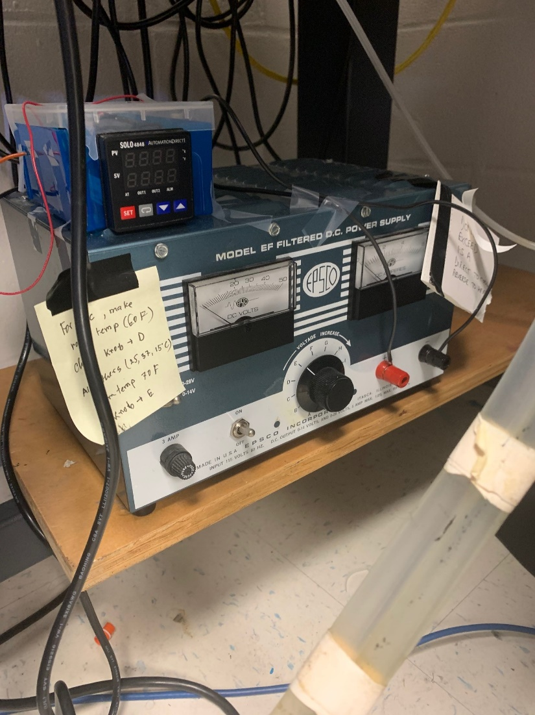

Figure: The AC to DC converter. This converter is opened and closed by the SOLO controller to control the stage temperature.

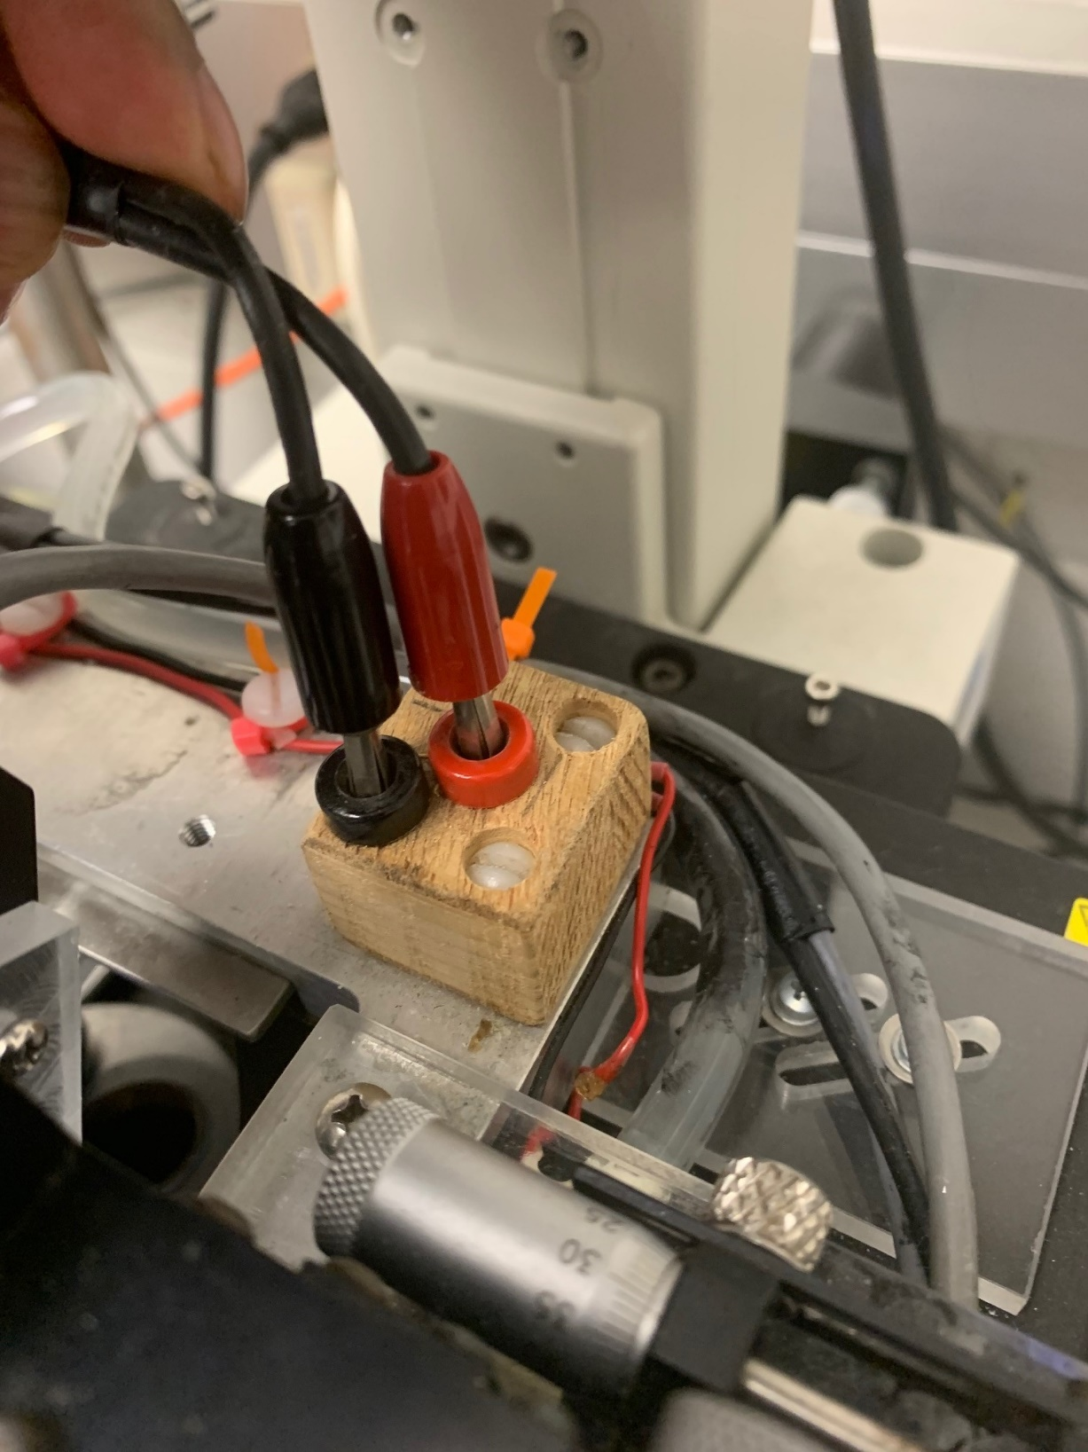

Figure: The black and red male connectors (from the AC to DC converter) are being connected to the black and red female connectors (located on the stage).

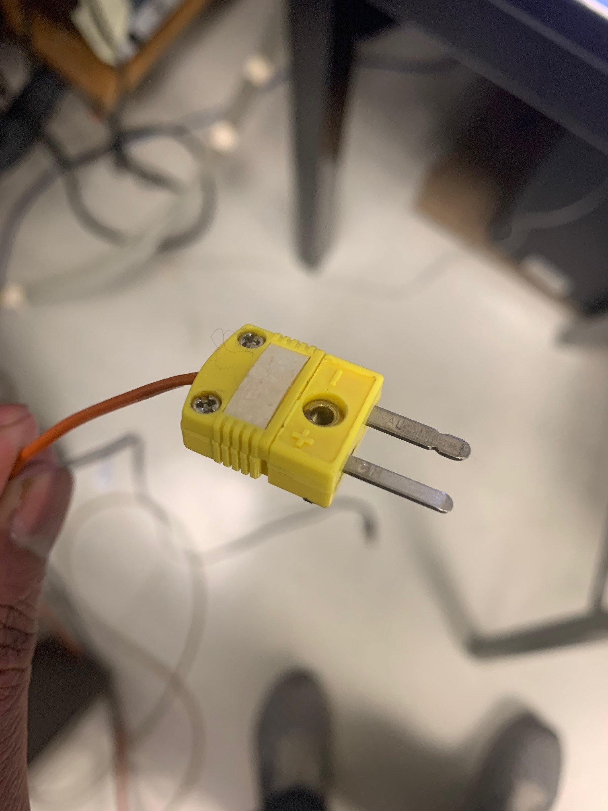

Figure: the thermocouple end which will be connected to the stage.

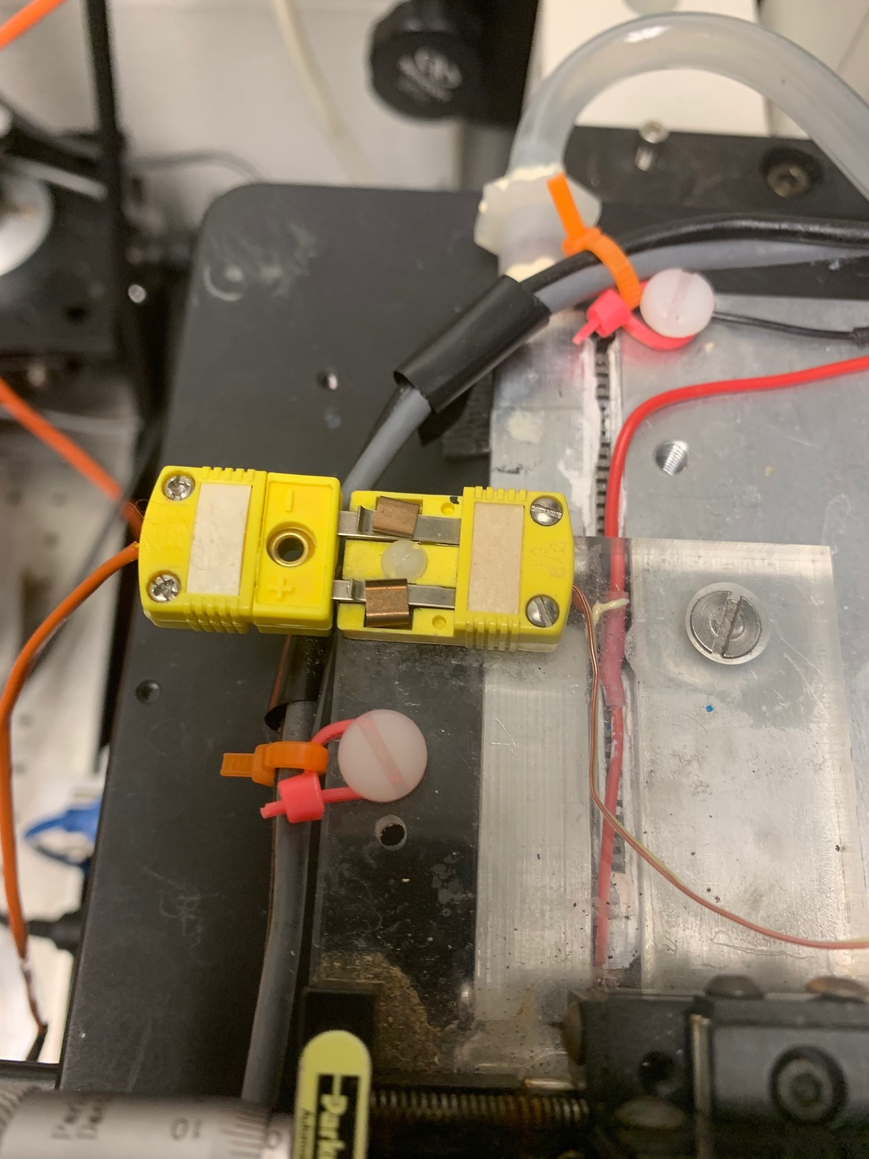

Figure: the thermocouple end was connected to the stage. It will go in only one way and it has + and – sign. If it does not go inside, you might want to rotate it.

1. **Set up the SOLO temperature controllers:**

The SOLO 4848 controller is used to control the AC to DC converter. When the stage temperature is different than the set temperature (aka target temperature), SOLO controller connected with a thermocouple will determine the temperature difference between the current stage temperature and set temperature. Then, it will turn on the DC converter box to send a current to the stage. If the temperature difference is high, the controller will send a longer signal (indicated by the movement of the output voltage indicating hand). If the temperature difference is low, the controller will send a shorter duration of DC.

How SOLO set the DC output duration? – In short, using the PID values. In a long answer, the SOLO controller uses PID controller mode (or other modes of your choice, but we set up the SOLO to use PID). PID stands for Proportional Integral and Differential. So the controller uses a P, I, and D value to determine how long the output should be opened to reach the temperature. PID values will depend on the temperature difference between the set temperature and the room temperature. So, setting up room temperature is important. To get PID value for each temperature you will have to “Auto Tune” the controller (details below). To learn more about PID controller, you may ask my best friend, who is I suppose your best friend too, Google.

The stage has Peltiers connected between the metal part housing the pCa solution baths and the outside metal part housing the water flow chamber. These Peltiers can transfer heat from the stage to the water or water to the stage for stage cooling and heating respectively. The direction of the heat flow is not determined automatically. Rather, it is done manually. You will see that one black and one red male socket connected with two wires which come out from the DC controller and the stage has one black and one red female socket on it. For cooling the stage, you need to manually connect the black male to the black female and the red male to the red female. For hearting, black to red (details below). If you forgot to do so, the stage will start heating when you want it to cool and vice versa.

Steps need to complete to set up the temperature controller:

* 1. *Set a temperature (SV, Set Value)* – simply use the upward or downward arrow to set the expected temperature

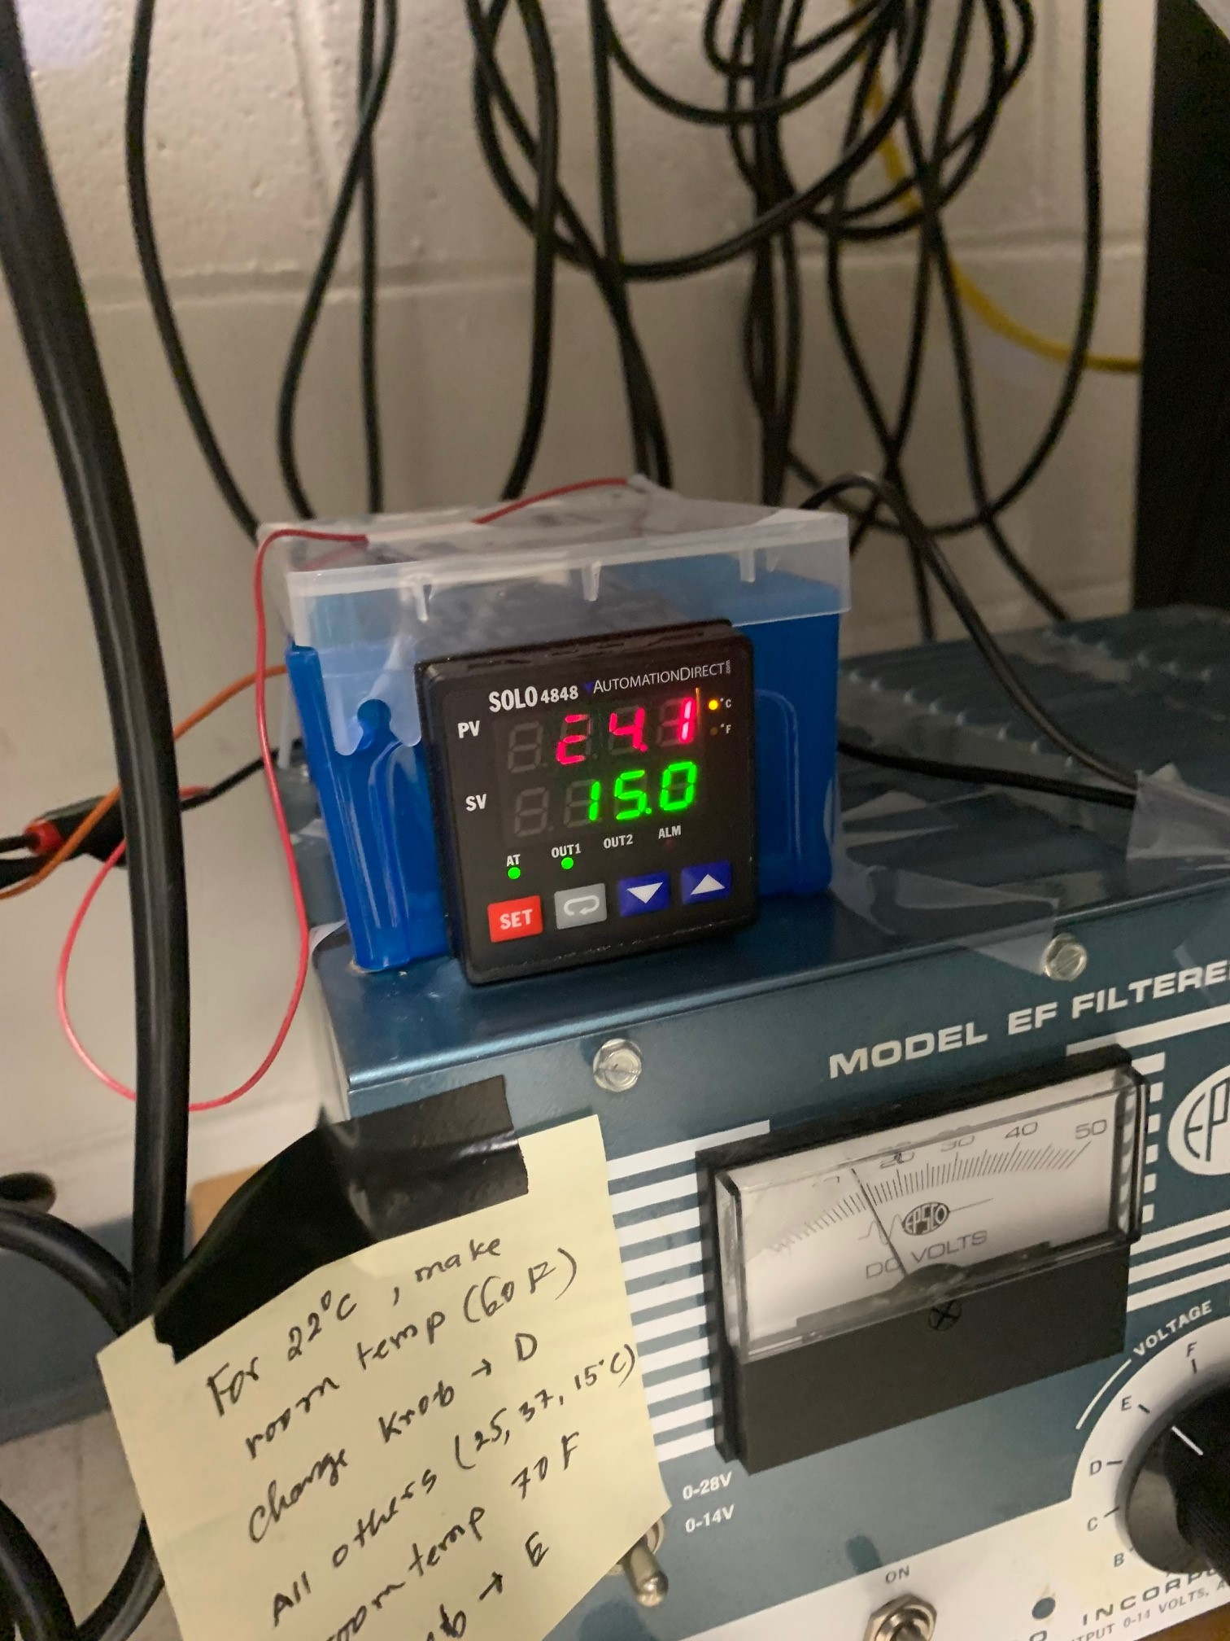

* 1. *Select an appropriate set of PID values* – click SET and then repeatedly click on the circular arrow button (between the SET and downward arrow buttons) to go to PID0, PID1, PID2, PID3 or PID4. Each PIDx will be associated with a temperature showed in green (next image). Using the upward or downward arrow, you can find a PID that matches your target temperature. For example, the following image shows that PID2 is associated with 15 C. It means someone has tuned and saved the PID values for 15 C at PID2 before and you don’t have to find the PID values now. Given you use the have room-temperature setup. If none of the PIDs’ temperature matches with your target temperature, you will need to “Auto Tune” to obtain the PID (go to Auto Tune in the following discussion to know how to auto tune). If you find a PID set that matches your set temperature, you can select that PID set. For example, PID3 is associated with 37 C and your target or set temperature is 37 C. Choose PID3. Press the SET button to select this PID set (or any option in the SOLO controller). Press the SET button to get out of the set mode.

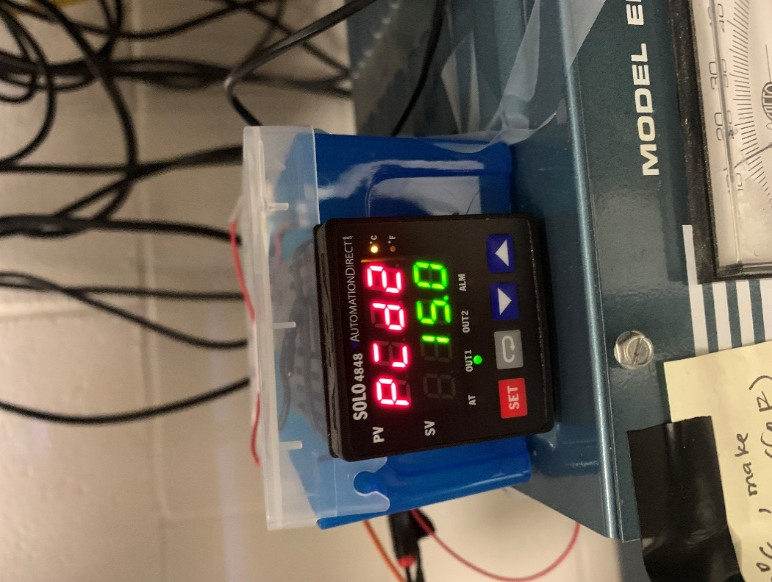

* 1. *Set heating or cooling mode:* If the room temperature is higher than the set temperature, you need to choose the cooling mode and otherwise you need to choose the heating mode. To setup heat or cool mode, press and hold the SET button for 6 seconds, then use the circular arrow button to go to 5-HC (like the following image), the use the upward or downward arrow to select Heat or Cool. The word “Heat” and “Cool” will start blinking, press the SET button to select this option. Press the SET button to get out of the set mode.

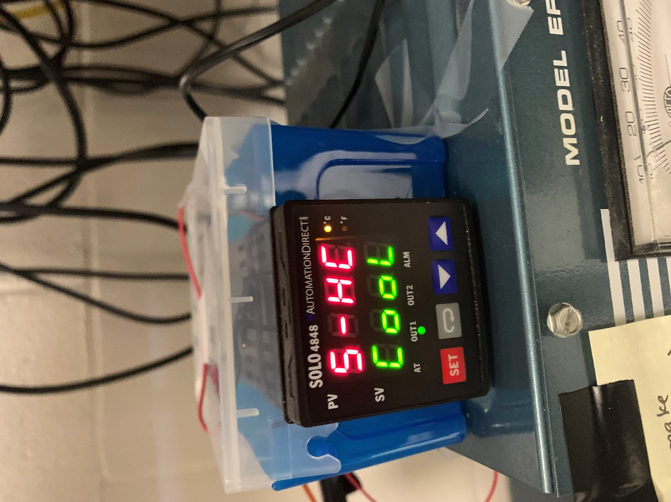

* 1. *Power output from DC output*- We are using the PID controller (aka SOLO) to switch on and off the DC output generated by the AC to DC controller. To obtain a high temperature difference, you need to use high DC output too. But if you use too high DC output, you will burn the wires used in the stages. I have a cheat sheet posted on the AC to DC converter to know which output to use and which the room temperature to set. For example, for 22 C, set the room temperature to 60 F and DC output knob to D, for 25, 37, or 15 C, make the room temperature to 70 F and DC output knob to E. E will send 1.5A while D will send 1A through the wires.
  2. *Auto Tuning –* If a set of PID values are not available for the target temperature, you will need to do “auto tune” to get a set of PID values appropriate for your target temperature. First, set the room temperature (section 1), set the target temperature (section a), choose a PID to overwrite (section b), set heating or cooling mode (section c), and set a DC output mode (section d). Now, press the SET button once, the Auto Tune option will come right away (as the following image). Use the downward arrow to change OFF to ON. Press the SET button to select the auto tune option. Press the SET button to get out of the set mode. It will start auto tuning and a blue LED will start blinking under AT (above the SET button). When auto tuning is done, the blue LED under AT will stop.

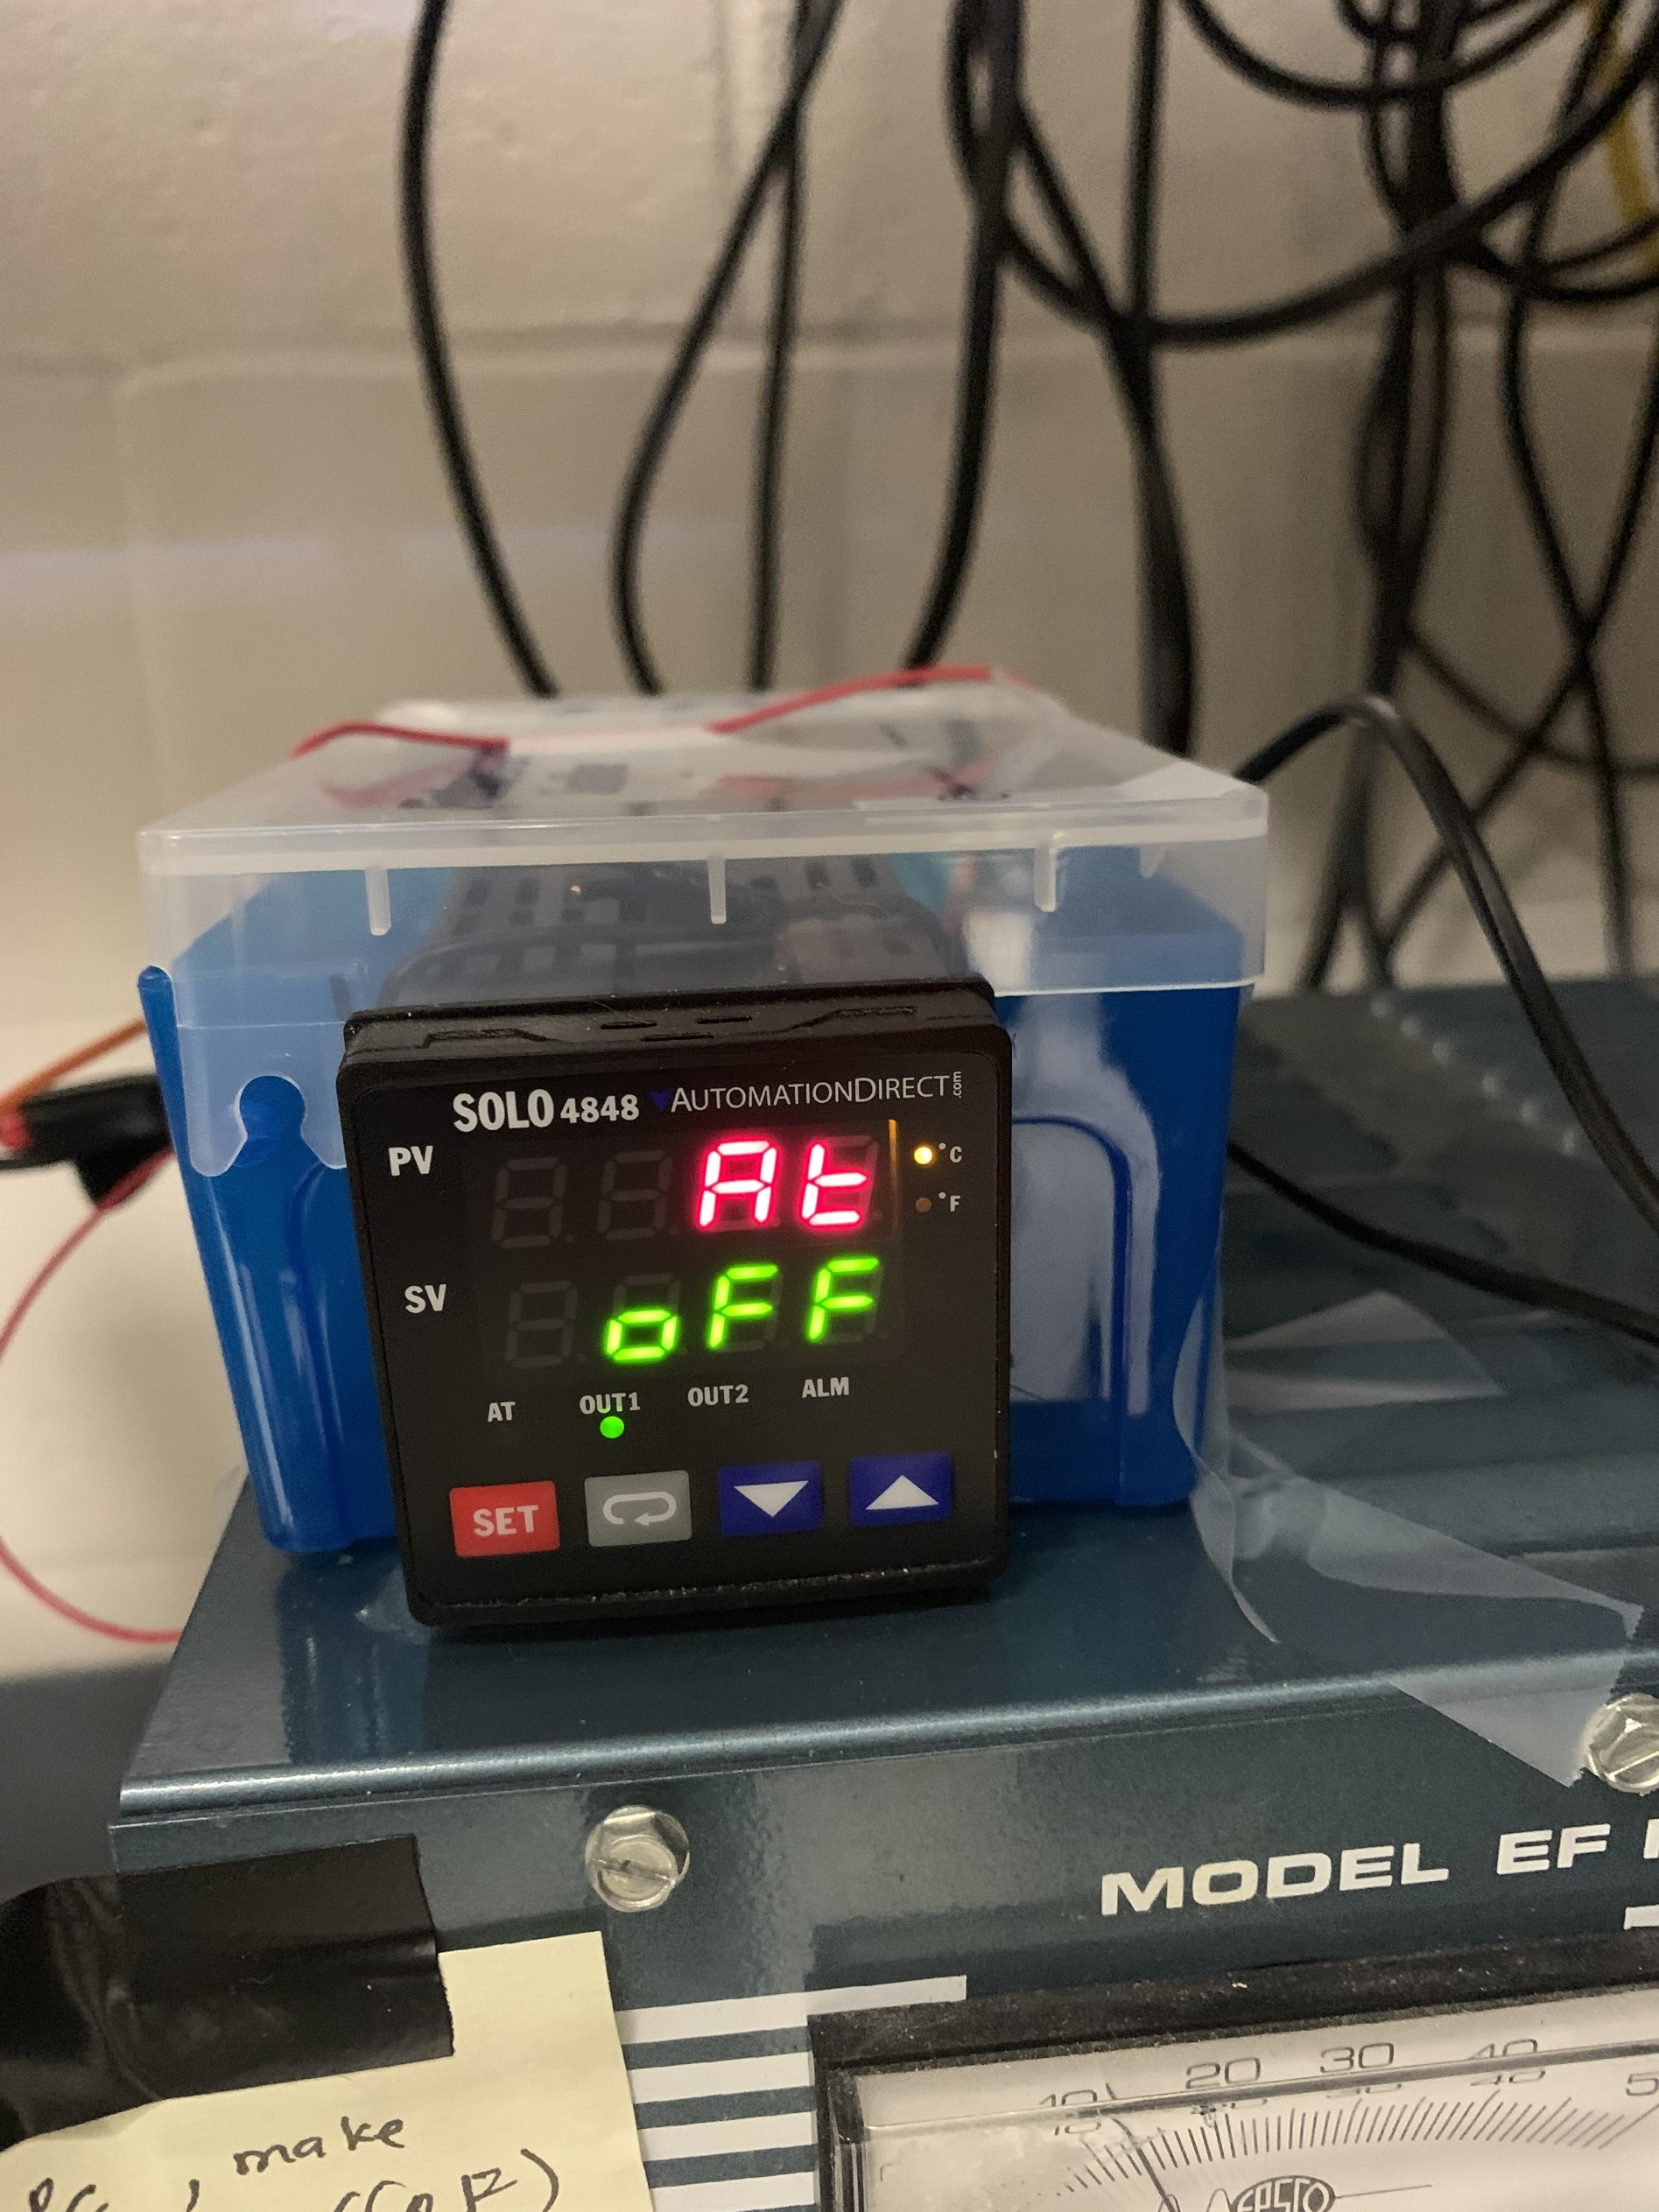

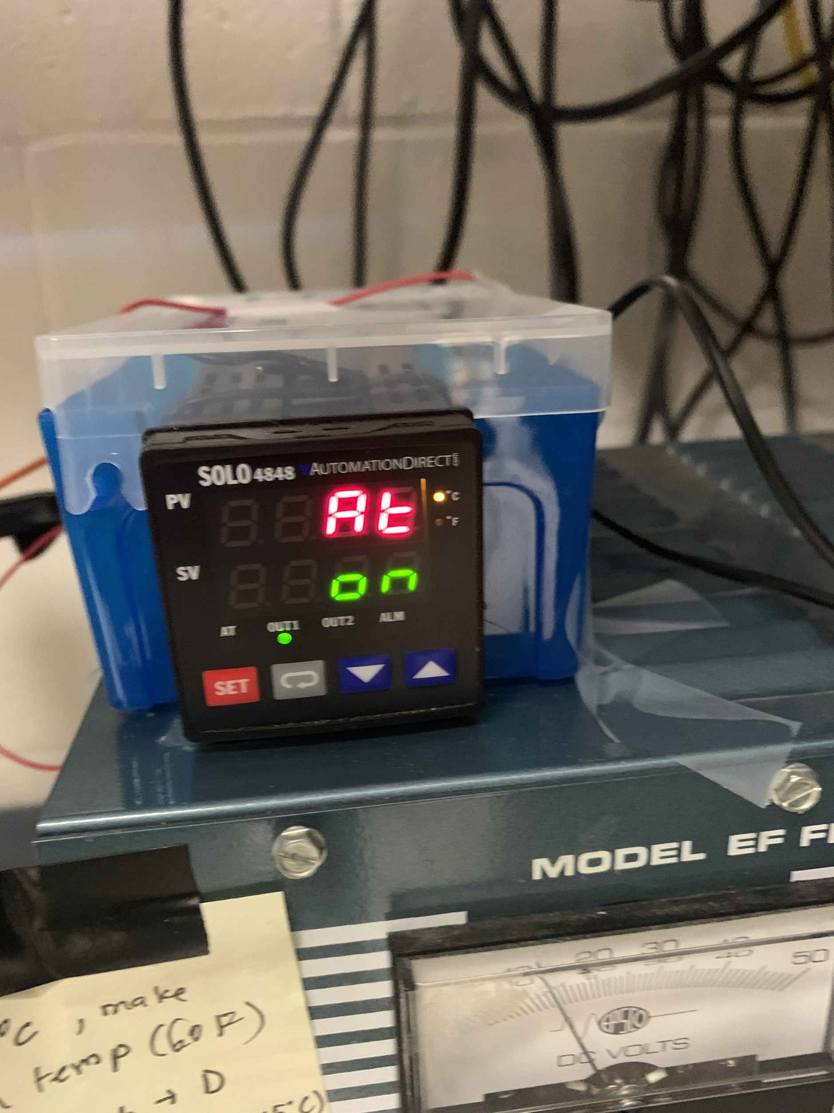

1. If you have done everything right, the temperature of the stage will start changing.
2. If you have any issues, please contact someone in the lab or Ken for help.